NHB+

Abundance

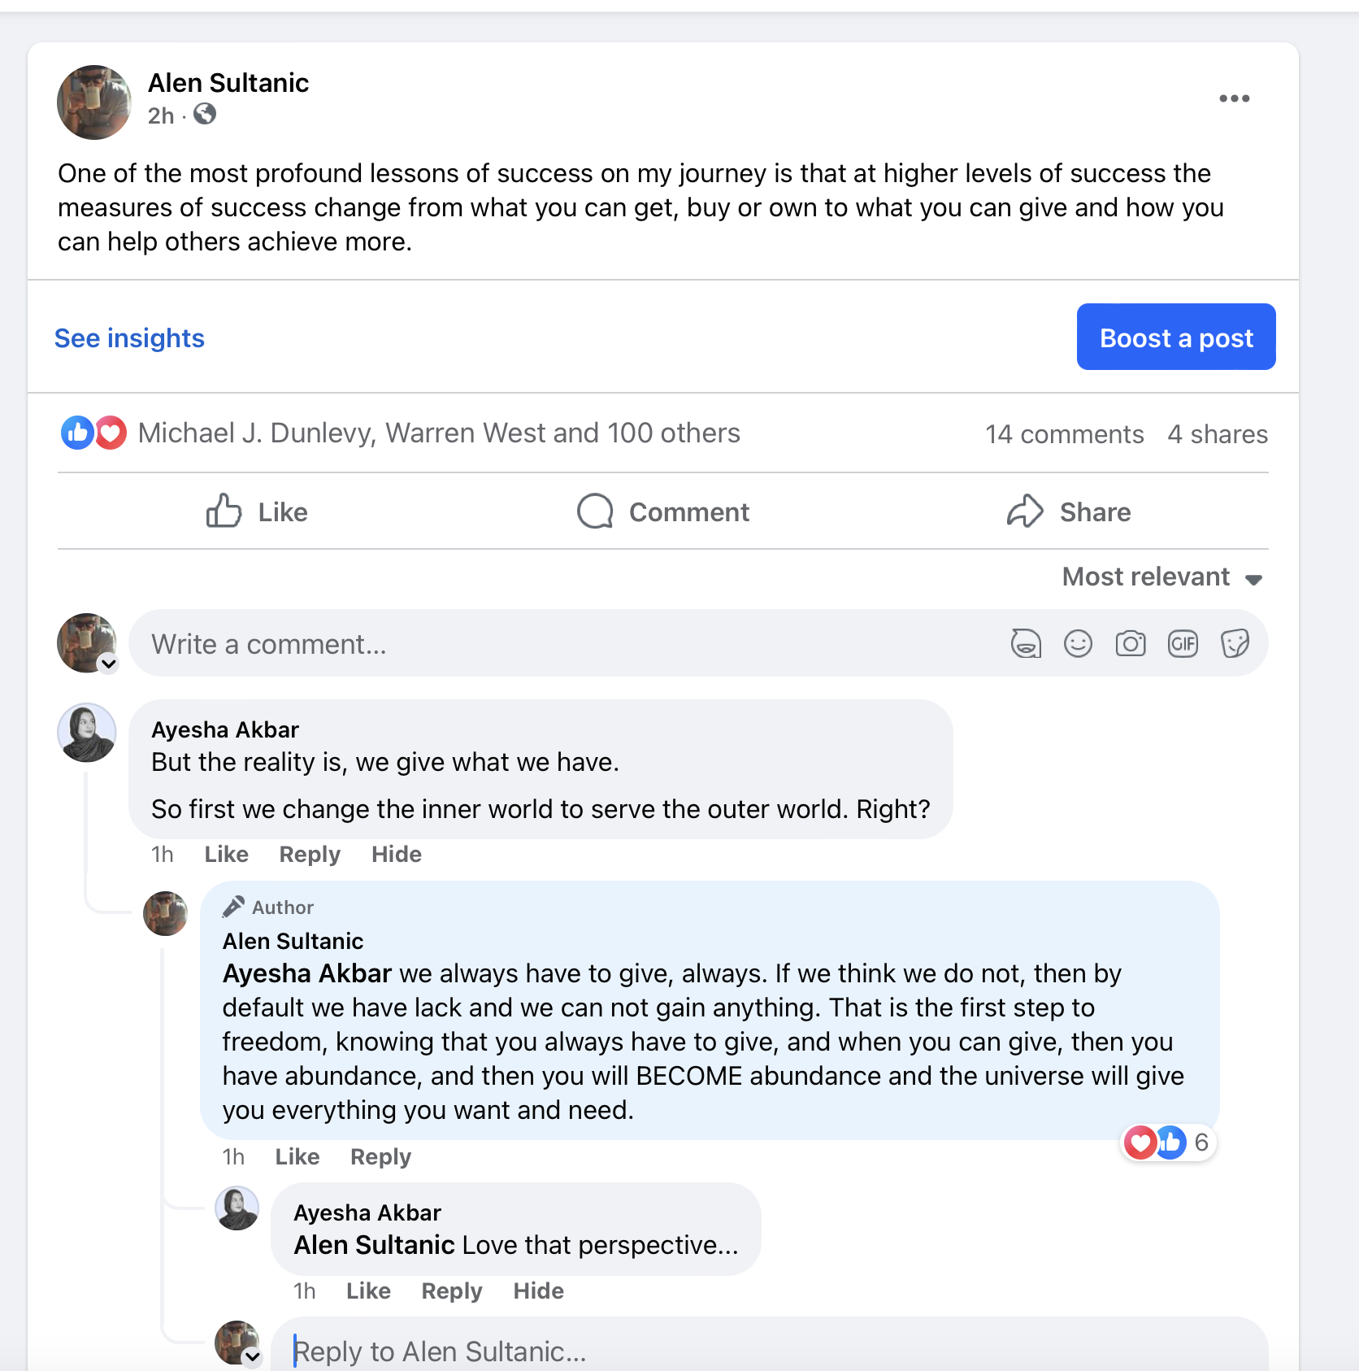

The way you speak to your subconscious is through behavior.

Being Selfish

Most of you do not have enough because you think you are selfish.

Yet selfishness can only exist as a perspective of someone else who doesn't get what you have.

If there is no one else around, then you can not be selfish.

If no one asks you for it, then you can not be selfish.

So why is it ok for them to control what you deem is acceptable?

The Ultimate Trap

What makes you happy?

- Freedom
- Laughing with other brothers
- Family
- Football
- Motorcycles
- Having options
- Self love

What would make you happy?

- Sail boat
- Skiing
- Food
- Traveling
- Brad a Grand Seiko
- House
- Helicopter
- Bigger house
- Lexus IS450 F Sport
- Sailboat
- House on a cliff
- A house in La Jolla
- Model S Plaid
- A deck with a hot tub
- A jagar
- Private Sauna
- Nice apartment
- NSX

Give me more freedom, adventures

Having an NSX would make me happy. Make me feel I could do it. Make me confident in something I wanted something as a kid.

A home with a bigger library would make me happy. It would give me more opportunities to question why I believe what I believe and to more quickly make new creative insights.

How many of you are like “this is a waste of money”

—

“Makes me”

If something makes you, it’s bigger than you.

A sign of very successful people is that they’re very decisive.

If something can make you, that something can unmake you.

House makes me happy because it represents _______________

When I focus on how or will this make me happy, I am saying that I have no choice

When I go to how am going to enjoy it, use it, whatever…this puts me in a position of choice

Because HOW and WHEN or WHERE is a choice direction

When you say this makes me, this owns you.

Makes me = desire

When you enjoy it, you own everything.

I enjoy it = will power

This makes me = you’re in a position of nothing.

I’m less and less if I have this.

Thoughts Into Emotions

As you know, copywriting, marketing, advertising, sales…is nothing more than change work.

In order to change, we have to communicate.

Without communication, we can not change anything.

All communication or lack of communication is to modify behavior.

There are many forms of communication, language, visual, feeling, etc…

We communicate through the 5 senses.

The reason being is a modification of behavior, is that behavior is just decision making.

Unless they take action, the behavior hasn’t been modified.

One of the things that gets humans to take action is sufficient emotional charge.

“When they feel it”.

Doing something is communication, but also not communicating is also communicating.

The most powerful skill to develop is knowing how to get other people to use their imagination.

The reason being is we can not convince anyone of anything. The only thing we can do is get in their minds, and do things that get them to convince themselves to do something.

Thought -> Language -> Feeling

You can not have thinking without time.

All purchase decisions / actions are made in feeling state.

Thought level - you have to convince them

Feeling - they convince themselves



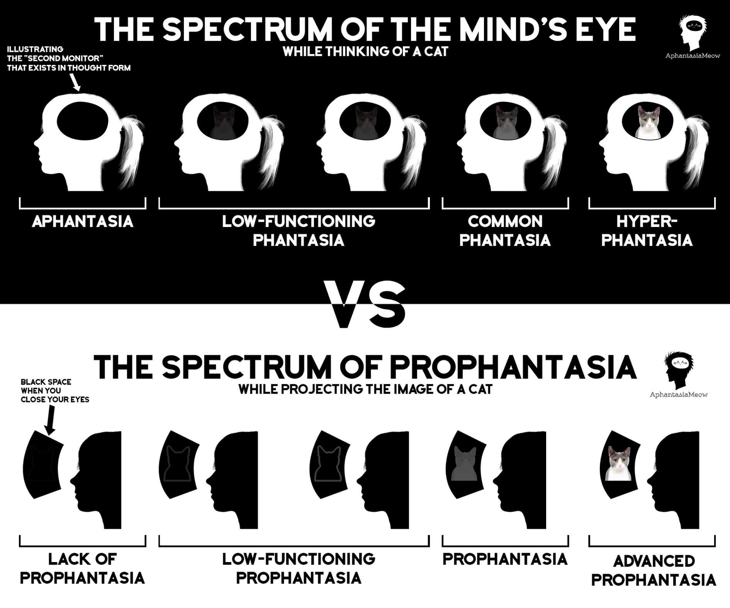

Engineering Problems

Market assumptions - we don’t launch offers, we launch problems. We don’t scale offers, we scale problems.

A problem is when you have two incompatible criteria and situations in one situation
One criteria / circumstance prevents you from having another but you want both

For humans, most problems are a lack of choice.

The resolution is which side of the problem is going to rise to the top

It’s only a problem if you have to choose

Typically it’s both that you want or neither that you want but have to choose

Create big problems. Solve big problems. Charge big fees.

The size of the problem is determined by the amount of resources/time it takes to solve it.

The urgency of the problem is determined by how much time they spend thinking about it contrasted against how much time they have to fix it.

Your audience always has a number of problems, so they have to choose which problem to deal with.

You get them thinking about it more, and you also get them thinking about how little time / resources / energy / money they have to fix.

What gets someone to think about something all the time?

“How does this make you ______________”

“This is going to make you” allow you, free you, enable you to…

“THIS”

- The journey to the future is fueled by 3 limiting beliefs
  - Worthless - material possessions so it can MAKE THEM worthy
    - This car will make other people see that you’re X
  - Helpless - information that MAKES them or GIVES them HELP
  - Hopeless - something that makes them powerful

- This is why if you take current event such as news etc…ATTACH THEM TO AN OFFER / COPY IT CONVERTS BETTER
- THINK OF IT AS TOP OF MIND AWARENESS

The things they think about - are the things that affect putting them in an unsafe place

All value is future value

You can not be afraid of something in the past. In order for something to excite you or affect you in a negative way, it has to be in the future.

All payoffs are in the future.

All products / services they buy or invest in, they’re buying and investing in a better future.

All messaging should be FUTURE paced. Because all change happens in the future, and thus this is change work.

People buy into the future outcome of the product

You bond to products in the future

It’s not enough that we imagine, we have to imagine what we get.

Now, the mind welcomes all that give it gain.

So when you’re selling something, you’re never selling the thing itself, you’re selling the after effect of it.

Time Orientation - the brain has time orientation

Future paced vs present paced vs past paced language - orientation of language. Words have time orientation in the mind.

The starting point is potentiality in passive narration, and this passive narration contains the seeds desire, a spark of desire that turn into action.

Once this happens, when this happens, when you do this….

When the brain is blank - you are happy.

Empty Mind

Vibration is heard or seen or felt

Thoughts

- A thought always has a boundary

In the mind we can not move in the 3d world, we move in the 4d world
- TIME
- YOU LOSE AWARENESS IF SOMETHING DOESN’T MOVE
Most predators where they hunt match their environment, you don’t notice them.

Lions, Jaguar, Ted Bundy and Jeff Dahlmer

You do not notice THOUGHTS that DO NOT MOVE THROUGH TIME

The more we move them THROUGH time, the more they lose awareness of time.
How much energy they have to expand to go through time will determine the level of desire and action potential.
The point in time you take is some transformative event

Since all marketing is change work, and you have to have time to cause change, that leads us to know that you move them through time to actualize change in their minds.

When you take thoughts through time, the time is the modifier that changes the story to the outcome.

You take a thought and you move through time.

A day, a week, a month, a year, a life.

You should have all of them in your copy.

As you move through time, if they GAIN, you generate positive emotions.

As you move through time, if they LOSE, you generate negative emotions.

Example for helpless:

Once you learn how the mind really works on a deep level, you’ll be able to know deep human psychology which will allow you to create offers and this will make you one of the best marketers in the game.

Then once you’re the best marketer in the game, people will recognize, see and hear about you.

you’ll be able = you can’t without it

- Can’t means I don’t want to or I don’t know how
- I lean into I don’t know, so I’m creating helpless

which will allow you to = you’re not allowed

- This is me taking permission control

this will make you = without this you are not one of the best marketers

- This creates a need, which has lack and creates desire

Then once you’re the best marketer in the game, people will recognize, see and hear about you.

- WIthout this, no one will recognize you, etc…

As I’m saying all this, I’m not saying anything. Because YOU ARE.

You are imagining all this happening to you.

The feeling starts to be generated.

Anticipation, excitement, possibility, hope, etc…

Example for worthless:

Once you learn how the mind really works on a deep level, you’ll be able to know deep human psychology which will allow you to create offers and this will make you one of the best marketers in the game.

Then once you’re the best marketer in the game, you’ll be able to launch offer after offer, and make as much money as you want.

How much you make and what you spend it on is entirely up to you.

If you want that Lambo, it’ll be yours.

If you want that penthouse, it’l be yours.

When you go out, people will recognize you and come up to you asking what you do for a living.

And when they ask you for what time it is, you’ll check your Rolex or Patek to see what time it is.

When you take thoughts through time, the time is the modifier that changes the story to the outcome.
- You could do that - this has the most trade offs - but you could also do xyz
  - The lowest level of potentiality
  - The strategy here is to devalue the other COULDs
  - You always start with the negative of what ELSE they could do, than go into what they COULD do which your positive
- You might do that - IF (something is here)
  - If this is a better alternative to that
  - If it’s compatible with something else without having to make the trade off
- You would do that - IF (something is here)
  - Than this is the willingness
  - If this is a better alternative to that
  - If it’s compatible with something else without having to make the trade off
- You should do that, BUT (something is here) - PUSH MARKETING
  - Should is a rule that they tell themselves
  - Internal dialogue, they don’t stick to this, because it’s a narration that is coming from something that is coming from something that they should
  - They are taking someone else's rules, societies etc…and they are implementing someone else's rule
  - Human beings generally don’t like to follow someone else's rule
  - Most get stuck here…I should but I can’t
    - Can’t has I don’t know how
    - I don’t want to
  - Most people live in the “I should” reality
- You will do that - PULL MARKETING
  - This is where will power comes in
- You are doing that - this is where identity work is done
  - This is commitment level
  - This is when the future is so interesting and compelling
  - This is how decisions are making

Final outcome
Problem State (Answer state) → Solution State (Question State)
- The actuation is I will do that - but I will do that is a trick because WILL DO THAT is a behavior not a thought.
- So there is a distinction between behavior and thoughts, and thoughts come first, then the feeling, and then behavior.
- Thoughts → Will Power (compulsion of emotion) → Behavior
What generates will power?

Who they become.

- Will power lives in decision making
- The Decision making process
  - Zoom in on what you want
  - When customers lose motivation, they lose will power.
- Decision making trade offs
  - You can achieve what you can’t achieve and what you can achieve
- Make a decision and stick with it, even if you decide not to decide, you still decided and are exercising will power, this is what drains will power. The indecision is what drains will power.
  - Knowing this, people are always generating will power and wasting it, so your job is to learn how to change it and channel it to what you want
  - You cannot not decide. Just by deciding not to deicide, you have decided. THis is why time exists, it decides for us or we can decide for it.
  - People that do not change, exercise a lot of will power.

Will power lives in decision making

- Excuse based language - language that has double / real meaning
  - Try
    - I did and failed
  - I can’t
    - I don’t want to
    - I don’t know how
Market status “I can’t”
-> I can’t build an offer
-> I don’t want to
-> I don’t know how to
-> Ok here’s how you do it
Ok now You would do that - IF (something is here)
I would do that if I couldn’t lose money on ads

  - Should
    - There is something lacking in me
    - There is a rule i’m violating
    - You should know better
      - You should do that
        - According to whom?
  - Wish
    - I wish I could
    - Wishy washy
    - It’s not firm, there is no solidity to it
  - Would
    - Future paced
  - Could
    - Future paced
This is why if you have a lead saying I SHOULD WANT THIS, vs I WANT THIS
Any sort of debt is directly related to time

This is why going into debt takes awhile to pay it off.

Story moves them thru time you lead them

Questions in Copy

The mind is absolute, blank when a thought comes it separates itself from the mind.

If you ask it a question, the mind has to expand energy to separate itself.

IF you tell a story it begins to separate through stories which is a seductive process.

The ultimate seduction is when they tell themselves the story.

All stories have time / future in common.

Transformative Words

It will show you ______________

It will take you ______________

It will transform the way you ___________

It will allow you to ___________

It will or it will make you

That means….

We are saying that you don't have to have will power, because this WILLS the CHANGE FOR YOU.

If you want to amplify desire - you move them through time, then show them how your product / service can get them there without energy expansion or spending much time - it can shortcut the time.

